Do Miracles Still Happen?

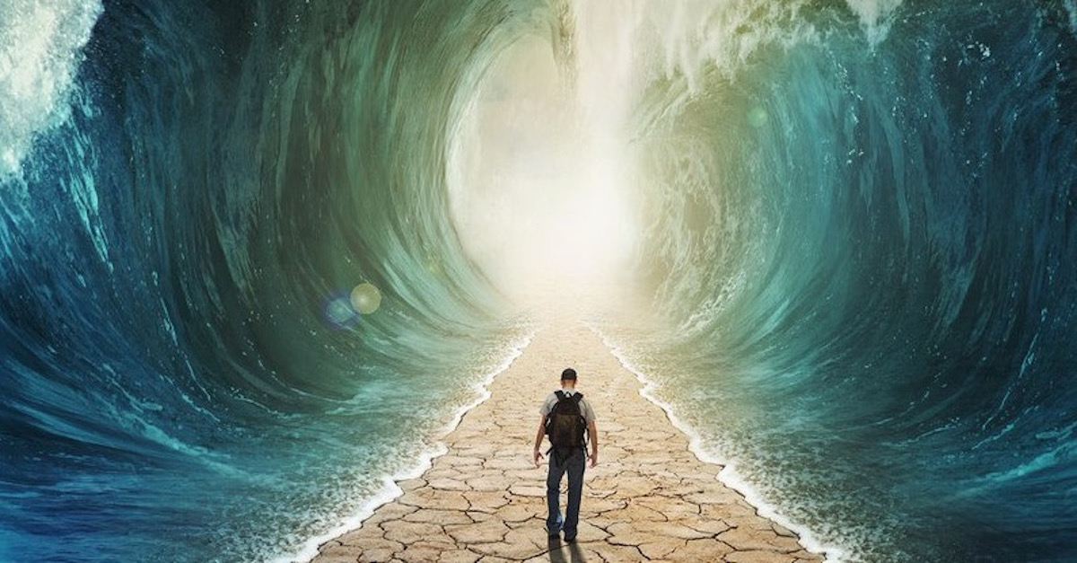

Pirkei Avos (Ethics of the Fathers) 5:5
Ten miracles were performed for our ancestors in Egypt and ten at the Sea...
Pirkei Avos (Ethics of the Fathers) 5:7
Ten miracles were performed for our ancestors in the holy Temple...

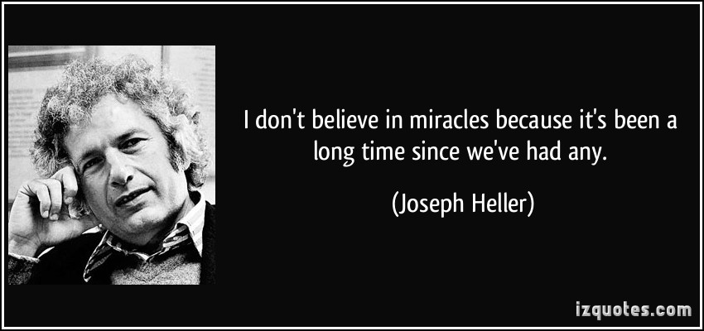

#1
Define miracle!

#2
Questions:
Do you believe in miracles?
Did you ever experience miracles?

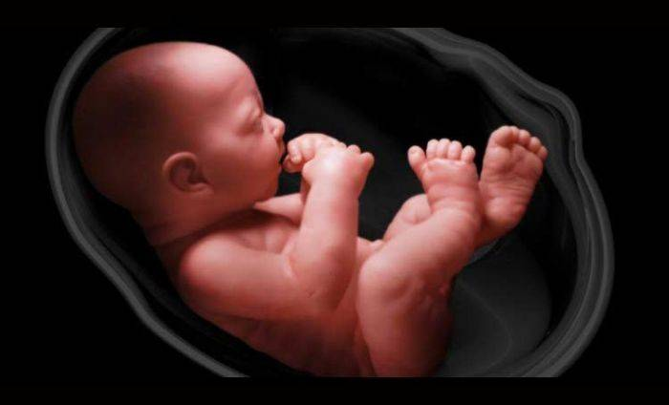

#3
Questions:
Do you believe in miracles or in G-d?
Will you believe in G-d if you were to see an open miracle?

#4
Based on Rabbi E.E. Dessler, Strive for truth and Rabbi D. Gottlieb, yeshiva Ohr Samayach
Two things we take for granted:
1) Cause & Effect (a causes b and it is predictable)
2) Permanence of the items in our world (items continue to exist on their own)
According to Judaism - nature has no objective existence; it is merely an illusion, deep illusion...similar to the way video works. It is a sequence of pictures. Each picture is a still picture frame, frames follow so rapidly that psychologically you assimilate, integrate it into a continuous stream of events.
The same exact reality applies to our three-dimensional, everyday world. The world is being recreated moment by moment from scratch, a brand new creation...
Siddur, Morning Prayer
...and in His goodness He (G-d) renews daily, perpetually, the work of Creation...

One prominent secular philosopher asked regarding this point: “Does this mean that G-d is fooling us?”
(a) Question: What could we reply back to him? Is it a mistake to conclude that G-d is fooling us?

(b) Question: Why did G-d make it look as if the world runs on its own, self sustaining?

(c) Question: If it isn’t really cause and effect, if everything is a brand new creation, then things could develop in any way and there is no control - should we trust cause and effect? Is there any point learning science, working on your career?

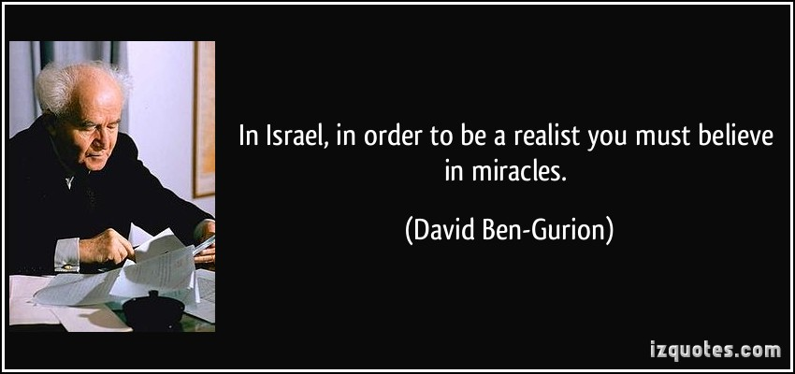

#5
Question: What’s practical application you gained from today’s discussion?

